Name: _Conway
Age: _9 Sex: _G
Date: _03/30/2018

Before:
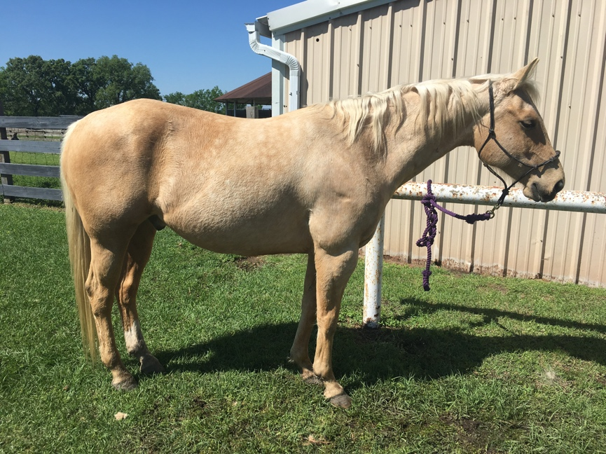
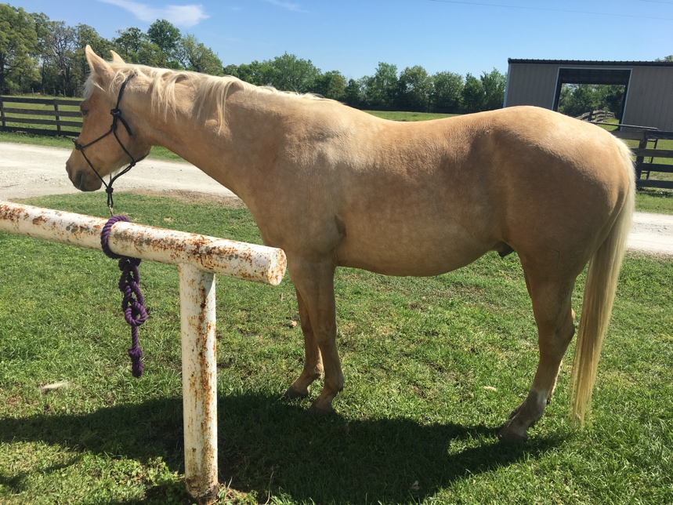
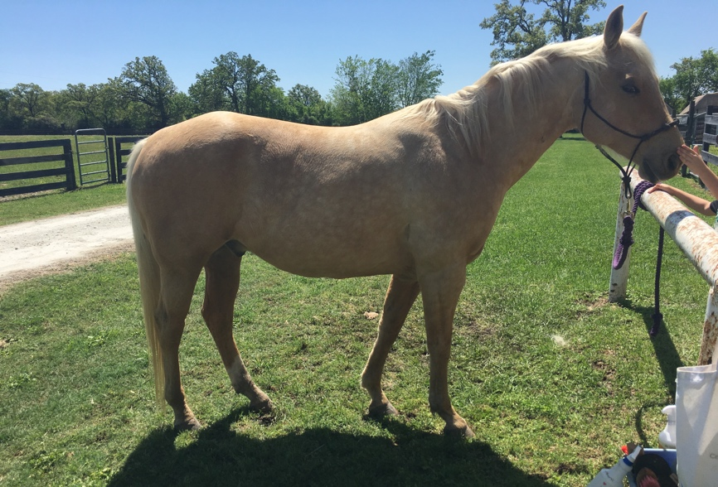
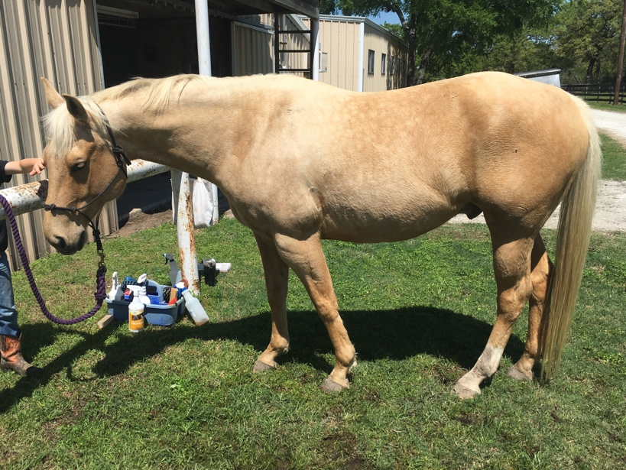
After:

Findings

Overall Health and Vitality: Before Session _62 After Session_84

Meridians Out of Balance: Stomach (In balance by closing)

Hooves: Calcifications- none. Barefoot.
Notes: Had soft heels and frogs, and thrush. On lush pasture.

Viral or Bacterial Issues: Y Hooves
Where and what’s needed- hoof soaks https://youtu.be/se6zmg3zNDE

Main Problems Presented Today:
Soft hooves, tight biceps/forearms, gaskin area, scoas. And sore SI

May I Work On You Today?: Y

Trapped Emotions: How many do you have? _5 How many can we release today? _5
Today we released: _Helplessness, unworthy, despair, defensiveness, frustration.
Tomorrow you can release: _

YIN/YANG Balances: North 6 South 4

Polarity Sweeps:_✅ “Fly-Bys”: ✅ Applied Release:_✅ Applied Miracle Spray:_✅ Worked K27s:_✅
Bladder Sweeps:_3x each side
Defense Posture Release, Both Sides: ✅

Areas Released:

C1-C2 Atlas/Axis: both- more reactive on R
C3-C6 Neck: Both-
C7/Scapula: Both- tightest on R

1 Wither: neither
Knees: Both- very mildly stiff
Elbows: Both

1st Rib: Both
Ribs 2-6 and Drunken Horse Pose: Both- had a hard time extending for drunken pose. Had tight pec/sternum/scapula
Ribs thru 18: All
Belly Lifts ✅

Psoas Release: ✅
Hips: R
Ischium/Ilium: R
SI Joint- Sore
Tail Pull ✅
Butt Tuck ✅
Belly Lift and Holds ✅

Closed Down Session w/ 2 Bladder Meridian Sweeps, Both Sides. ✅

*Disclaimer* This is not a diagnosis or meant to replace your regular veterinarian or chiropractic care.

If this were my horse, these are the actions I would take for optimal results:

- 3 days of no under-saddle work post 1st Bodywork session, hand walks and gentle large circle lunging are good if you must. Plus yoga poses each of those days.

- 30 days straight of Horse Yoga Poses, best if done pre and post rides after under-saddle work resumes. https://youtu.be/PKEL-aHCDsE

- Bladder Sweeps 3x each side before/after Yoga and/or a ride or in any stressful situation that may arise (travel, colic, etc)

- Daily shoulder/wither lifts on the 1 side ( L or R, not both) as noted above, until your horse get their next trim/shoeing (best to do this just before farrier works on them).

- Apply _10 drops of NCD2 _1 x day until bottle/s are gone, directly into their mouth or in a hollowed out carrot. Very import to give them before and after vaccinations, chemical dewormers, and other prescribed drugs. https://youtu.be/Xw9D_CujB3A

- Apply Trace Minerals to replenish minerals, use as a natural dewormer (copper), anti-bacterial/anti-viral for internal issues _3 droppers full on wet mash for _10 days. Externally can be used to push out infection on wounds for quicker healing.

- Apply Miracle Spray directly into their mouth or on top of food as long as they show interest to sooth digestion issues and boost immune system and/or their coronet bands, outer hooves, and under hooves/ frogs (imagine a whole hoof soak but it’s sprayed on instead of sitting in a soak).

- Apply Release Spray as needed on tight areas (head, whither, hind end, etc.), to reduce bruising, trauma, and/or over horse, or into mouth just to calm or relax them. Good tool if colicing.

- Apply Balm generously to arthritic knees and other Calcifications like Sidebone etc. See video for more instructions. Can also reduce old scar tissue.

